1.Launch one EC2 using Amazon Linux 2 image and add a script in user data to install Apache.
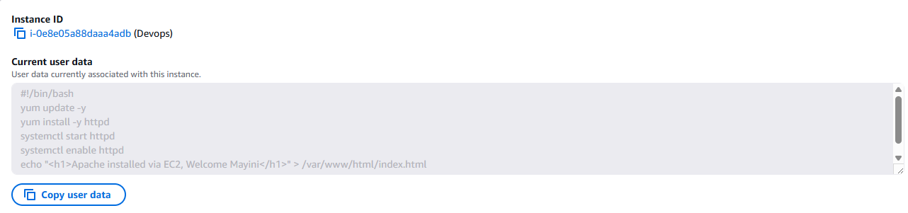
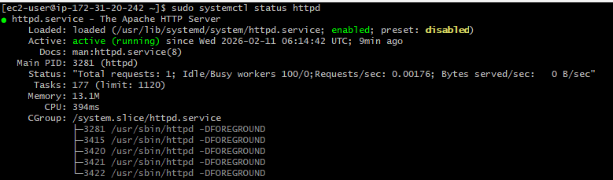
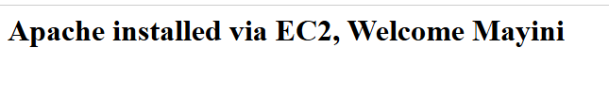
2. Launch one EC2 using Ubuntu image and add a script in user data to install Nginx.
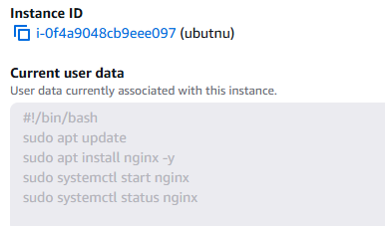
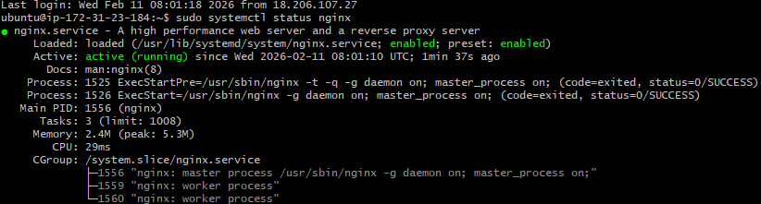
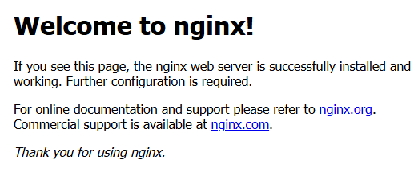

3. Launch one Windows server and install Tomcat on Windows.
i)Firstly launch an instance by using windows AMI.
ii)Then, Go to connect , and click on RDP client.
iii) After opening, the RDP client generate the password by using the .pem key.
iv) After generating the password, click remote desktop connection in search bar (in your local machine) and try to connect with your Ip address and password that has been generated using .pem key.
v) Later after connecting you will redirected to a new windows in that install Java 17 version and install tomcat 11 for windows and then run in powershell or command prompt.
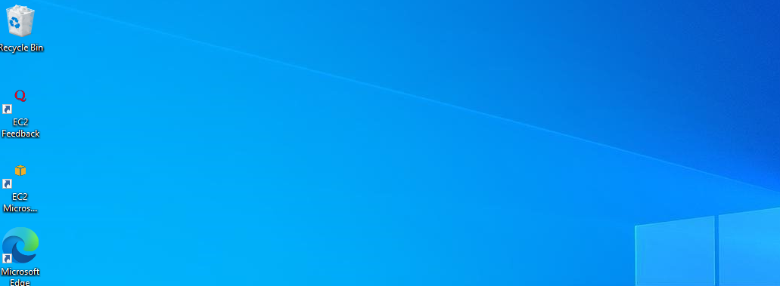
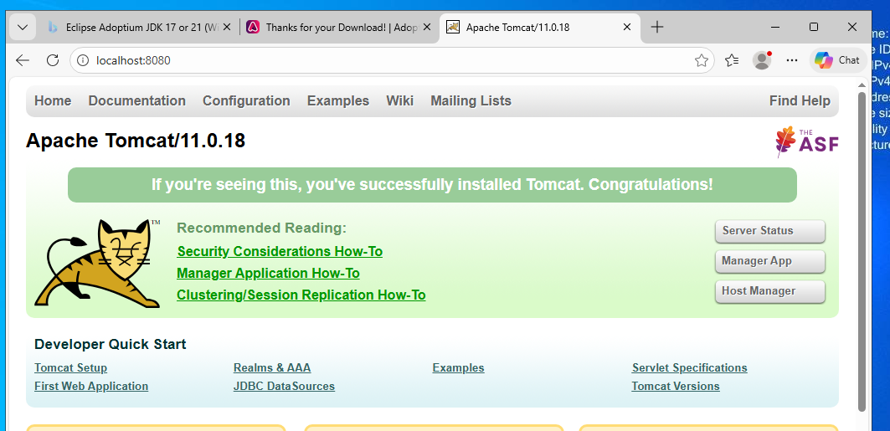

4. Take a snapshot of the instance created in Task 1.

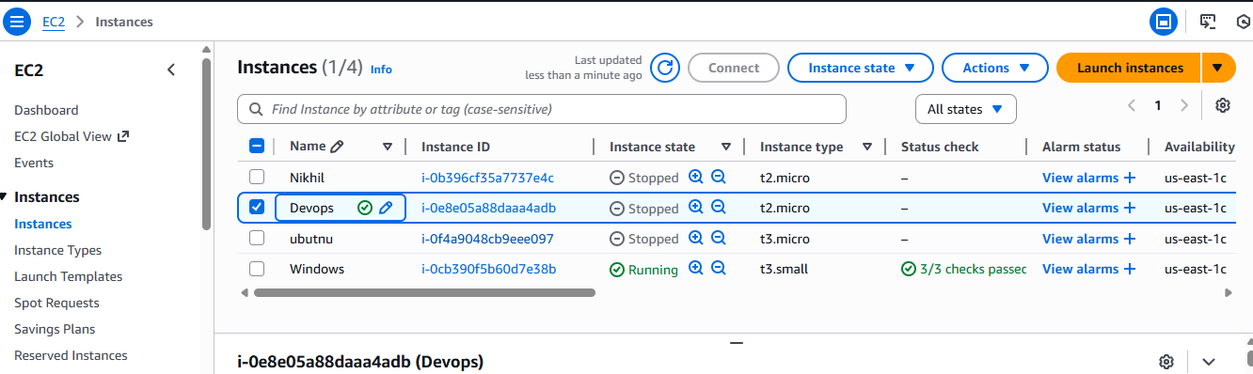

5. Assign passwordless authentication for the EC2 created in Task 2.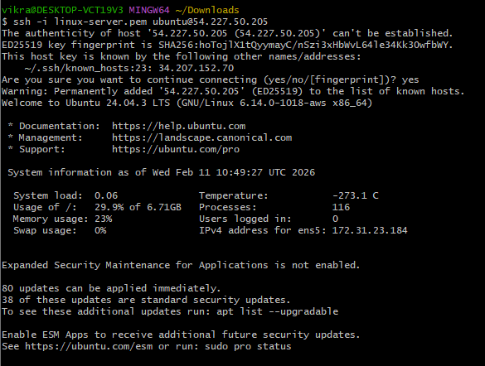

6. Launch any EC2 using the spot purchasing option.
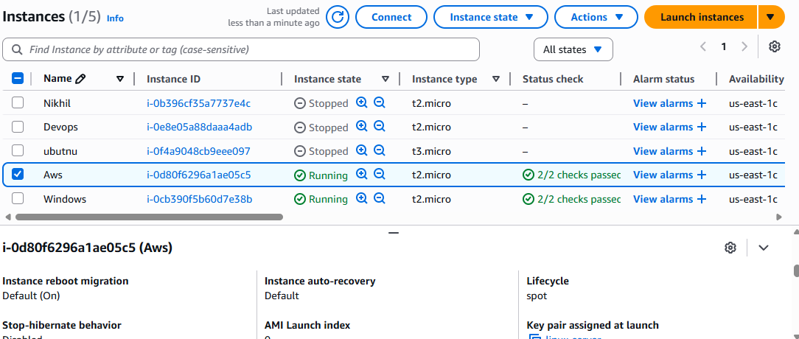

7.Enable termination policy on the EC2 created in Task 2.
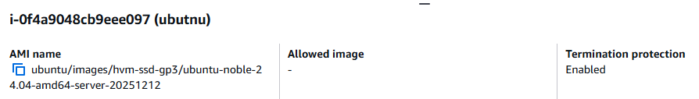

8. Launch one EC2 using AWS CLI.
